Machine: shelldredd

nmap ping scan:
Target IP: 192.168.56.113
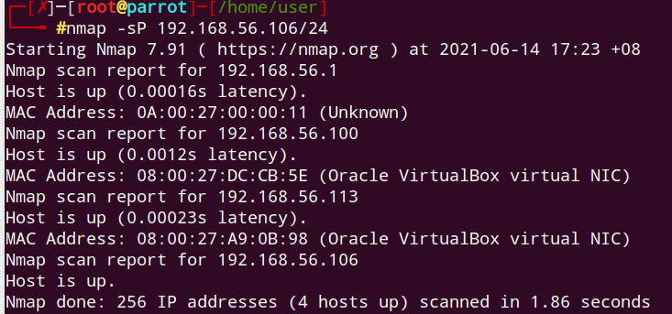

We confirmed the above results with netdiscover where the target machine ip is also 192.168.56.113:
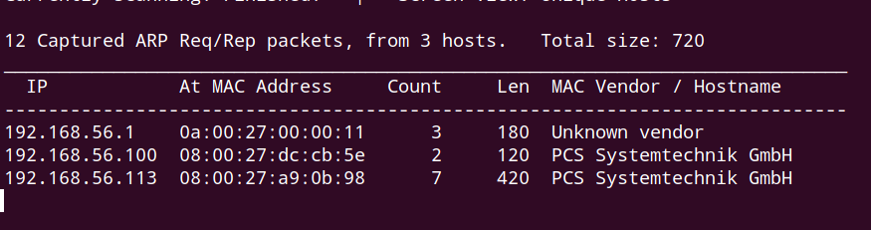

nmap udp scan:
Udp open port: 69
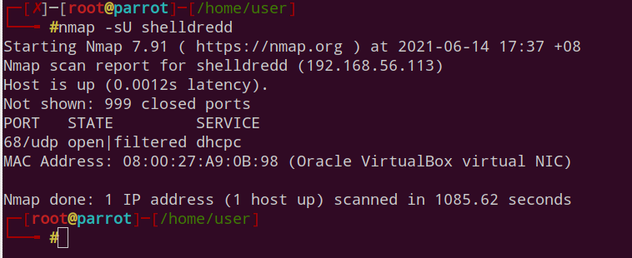

ftp enumeration:

Able to logon as anonymous user.
Hannah is a hidden directory.
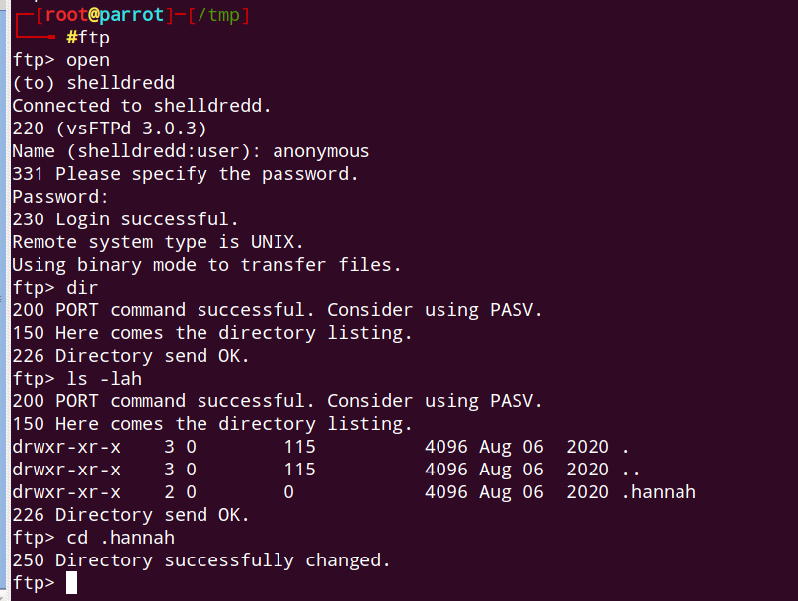

Download id_rsa which basically is useful to authenticate over ssh
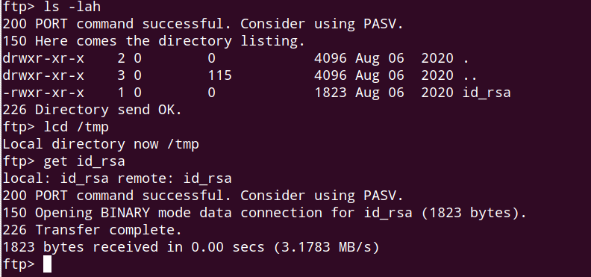

To pave way to logon as ssh:
1. Remove any existing keys on attacking machine.
2. Create new .ssh directory.
3. Chuck id_rsa in there and change its permission to 600.
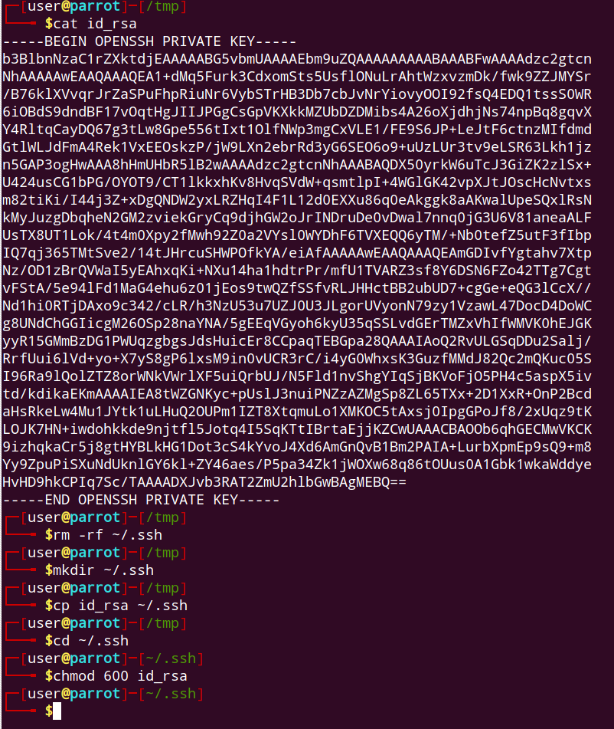

Initial foothold established:
We are logged in as hannah.
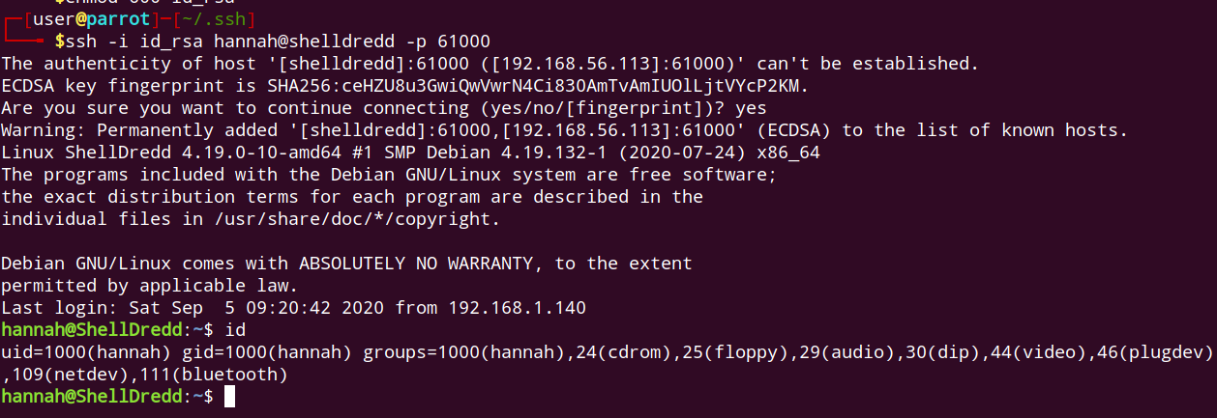

user flag:
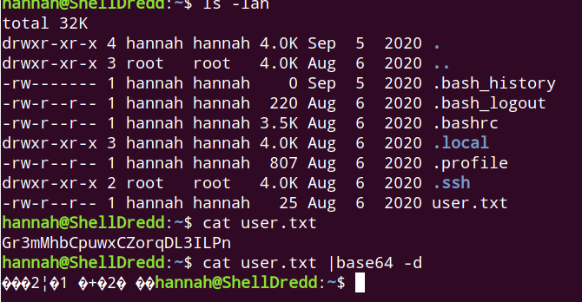

Interesting entries while hunting for suid binaries, namely cpulimit and mawk.
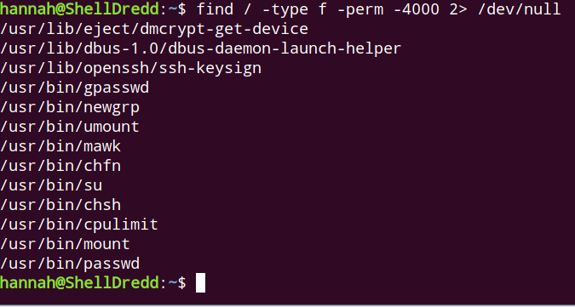

For mawk, am able to read shadow files. So far root password isn’t crackable.
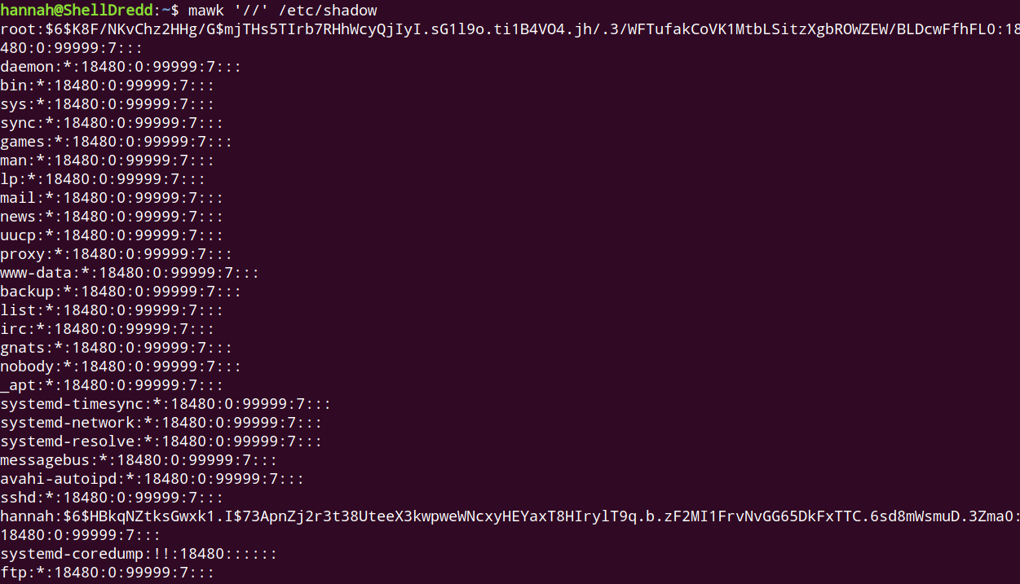

To escalate privilege using cpulimit, add suid bit to //bin/bash, then run shell as root by using //bin/bash -p.
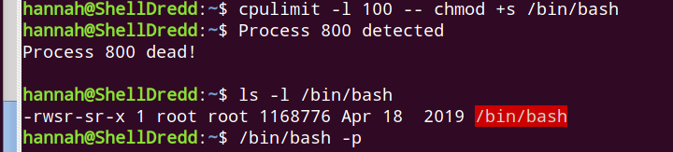

root flag:
